Chapter 11, Problem 79.

Determine the wattmeter reading of the circuit in Fig. 11.94.

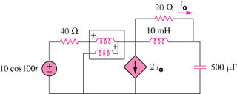

Figure 11.94
For Prob. 11.79.

